

**MIDDLE EAST TECHNICAL UNIVERSITY**

**DEPARTMENT OF ELECTRICAL & ELECTRONICS ENGINEERING**

**EE464 – PROJECT #1**

**Anılcan Budak (2093490)**

**Mert Elmas (?)**

**INTRODUCTION**

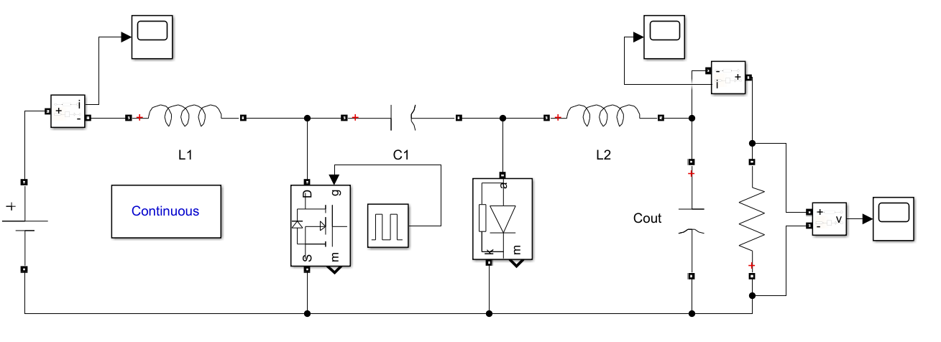

**Figure 1 :** Cuk Converter Design

**a)**

* Output Voltage: -12 V

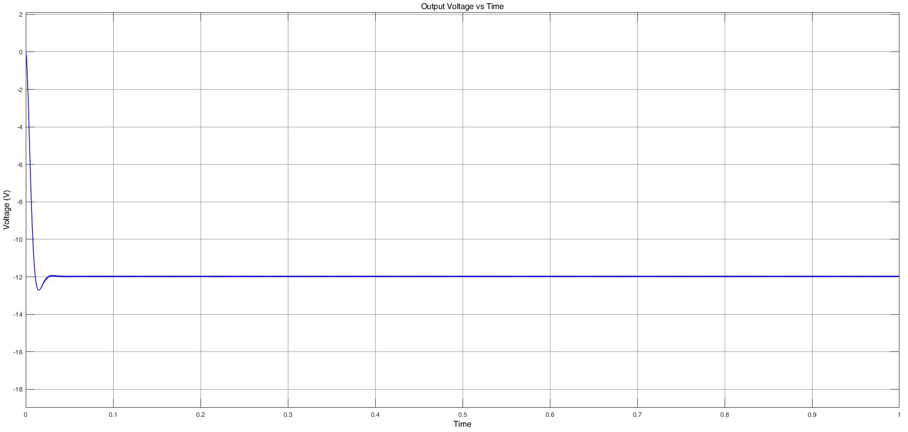

**Figure 2 :** Output Voltage vs Time Graph of Cuk Converter

* Output Current: 3 A

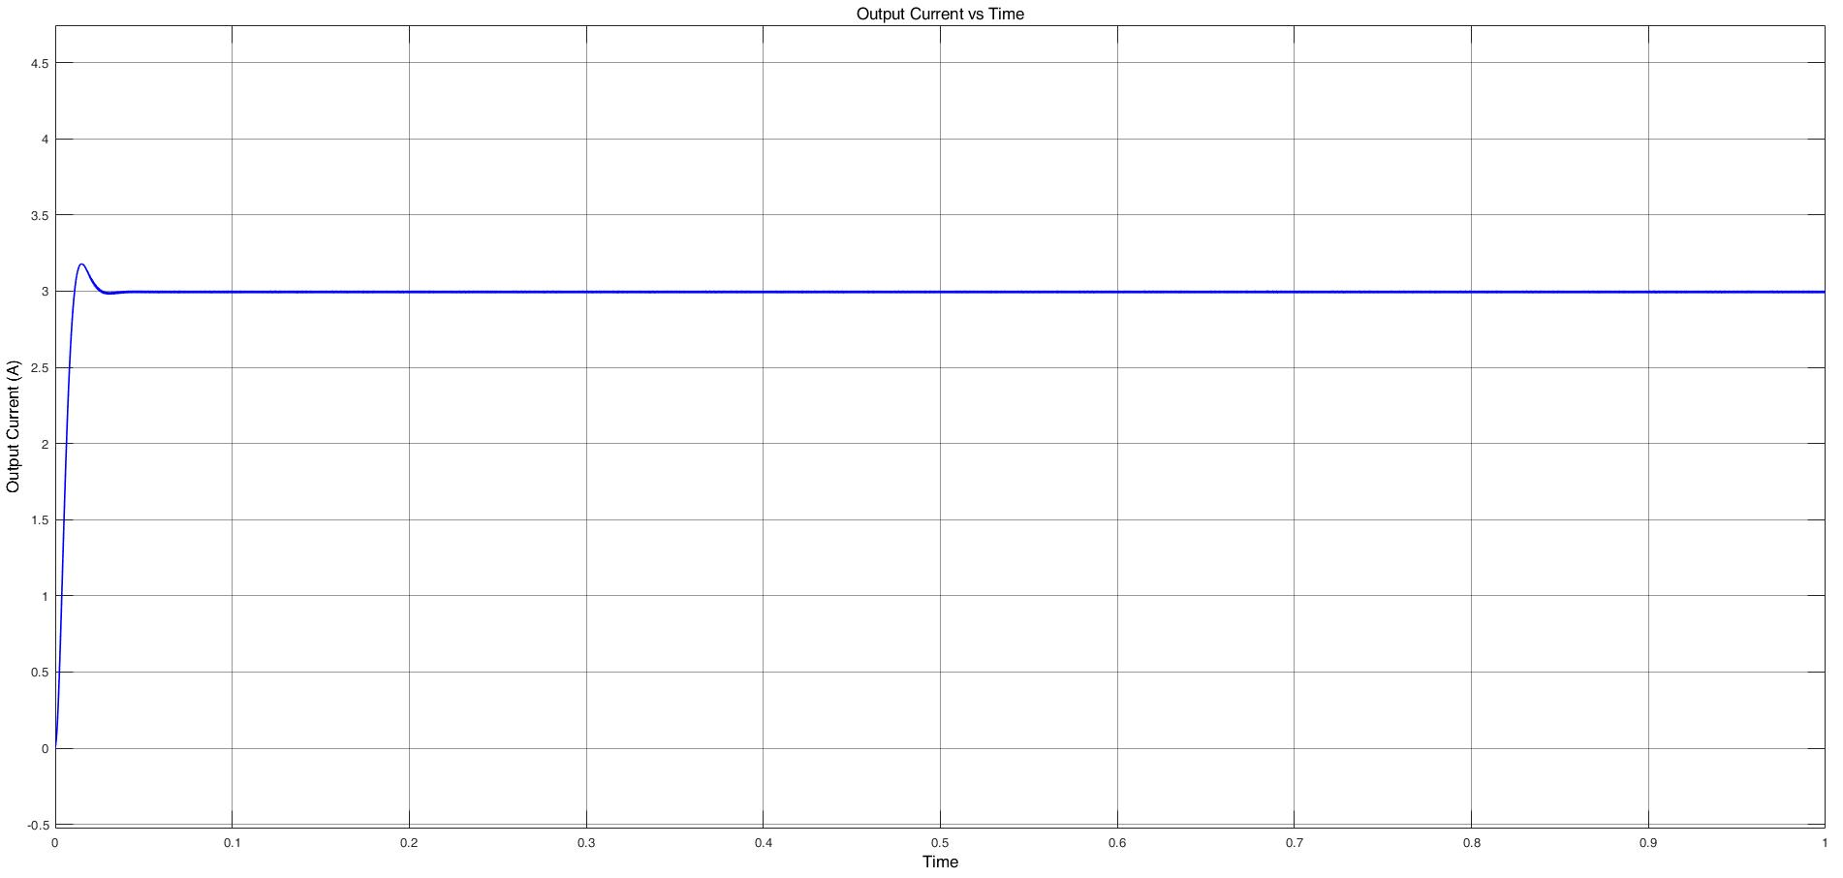

**Figure 3 :** Output Current vs Time Graph of Cuk Converter Design

* Switching frequency: 100 kHz

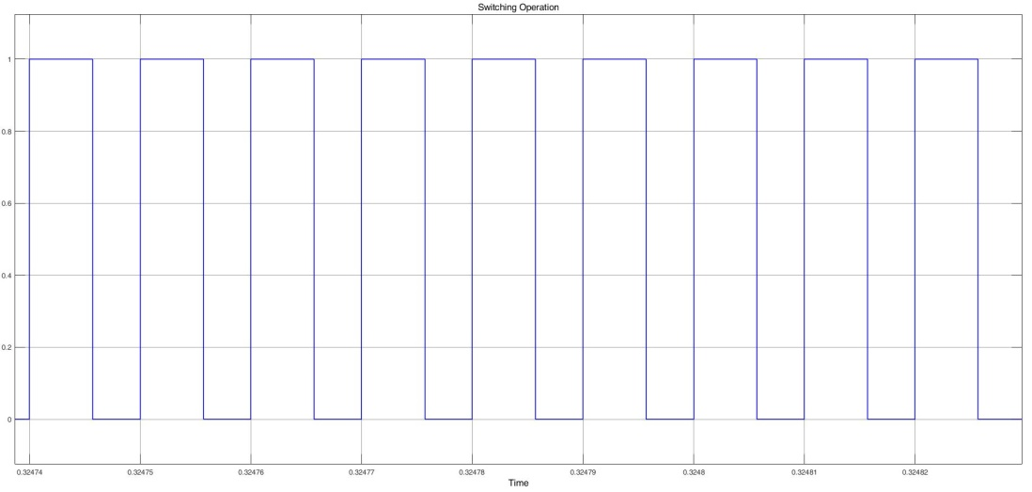

**Figure 4 :** Switching Operation at 100kHz and 4/7 Duty Cycle

* Max. Output voltage ripple: 2%

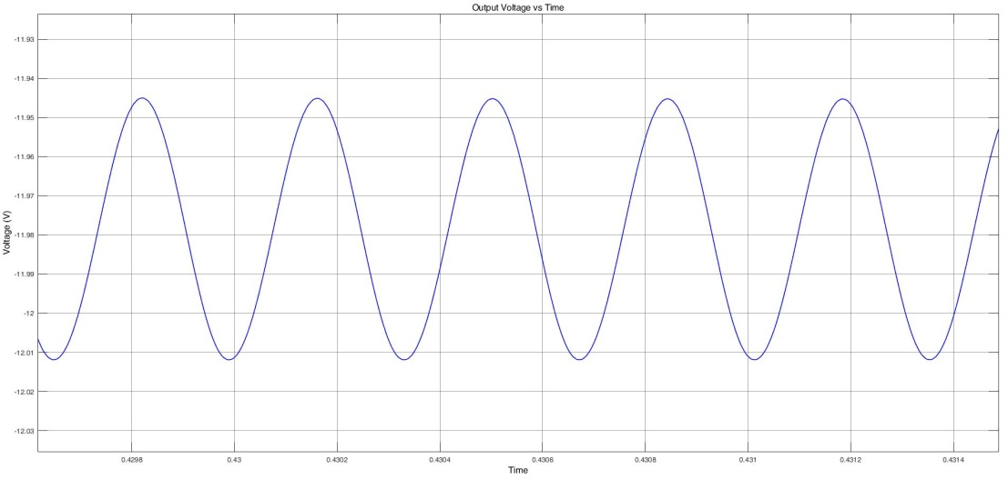

**Figure 5 :** Output Voltage Ripple Graph

The design satisfies all requirements as shown in the Figure 1,2,3,4 and 5.

L1  is picked 10 mH to keep source current ripple as low as possible.

C1 is picked 100 uF since it is the primary storage element it is selected large considerably. Also, ripple voltage at the capacitor is low.

L2 is picked 1 mH. This selection was out of our design considerations.

COUT is picked 660 uF to make sure that Vout is almost constant. (large enough)

Commercial Product : KerESMH401VEN661QR55T – 660 uF 400V Electrolytic

**b)**

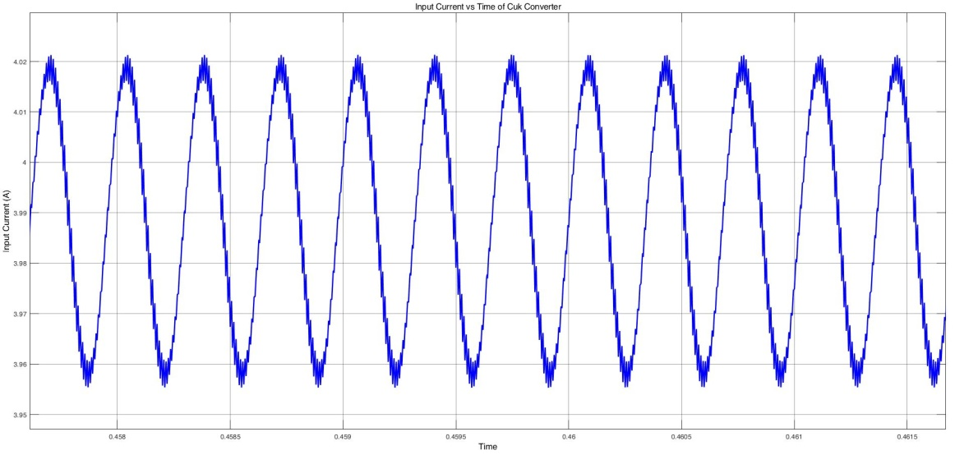

**Figure 6 :** Input Current vs Time of Cuk Converter

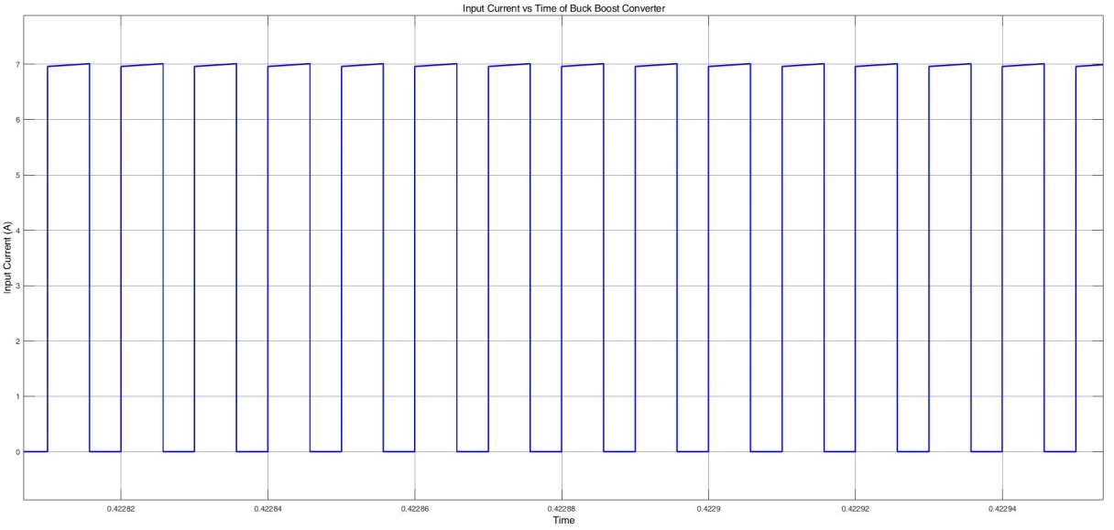

**Figure 7 :** Input Current vs Time of Buck Boost Converter

As can be seen from the Figure 6 and Figure 7 :

* Input current of Cuk Converter is almost ripple free whereas input current of Buck-Boost has very high ripples.
* Cuk converter works at CCM. On the other hand, Buck-Boost Converter works at DCM.
* Input current of Cuk has a sinusoidal waveform while input current of Buck-Boost has a square waveform ( THD of Cuk current is lower)
* It can be said that source current of Cuk Converter is almost constant.

**Comment :** In terms of input current, Cuk Converter is better than Buck-Boost Converter since it has a lot of benefits. Firslty, it works at CCM which is more preferable and input current drawn from the source is almost constant. Secondly, due to first advantage input current of cuk converter is ripple free but buck boost has very high ripples. Finally, current quality of Cuk Converter is better because its waveform is sinusoidal ( lower = better THD)

**c)**

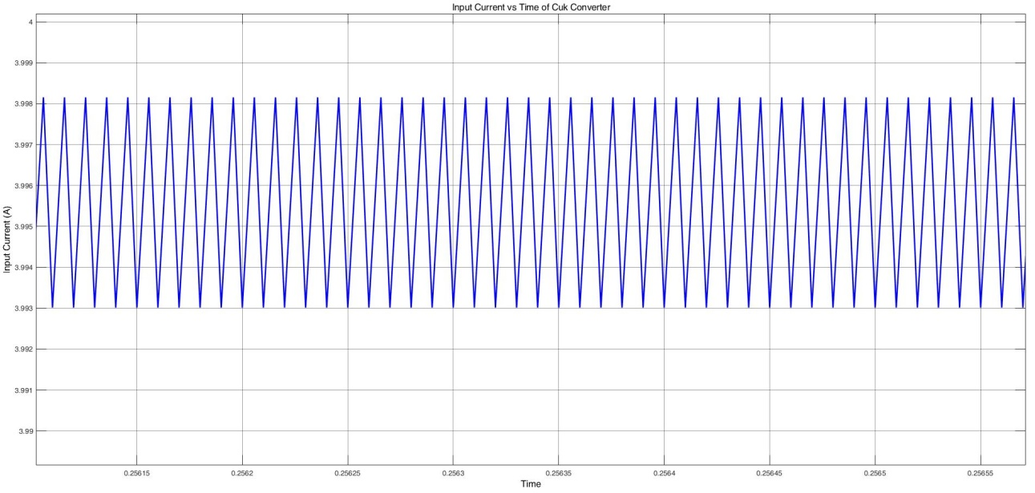

**Figure 8 :**Ripples

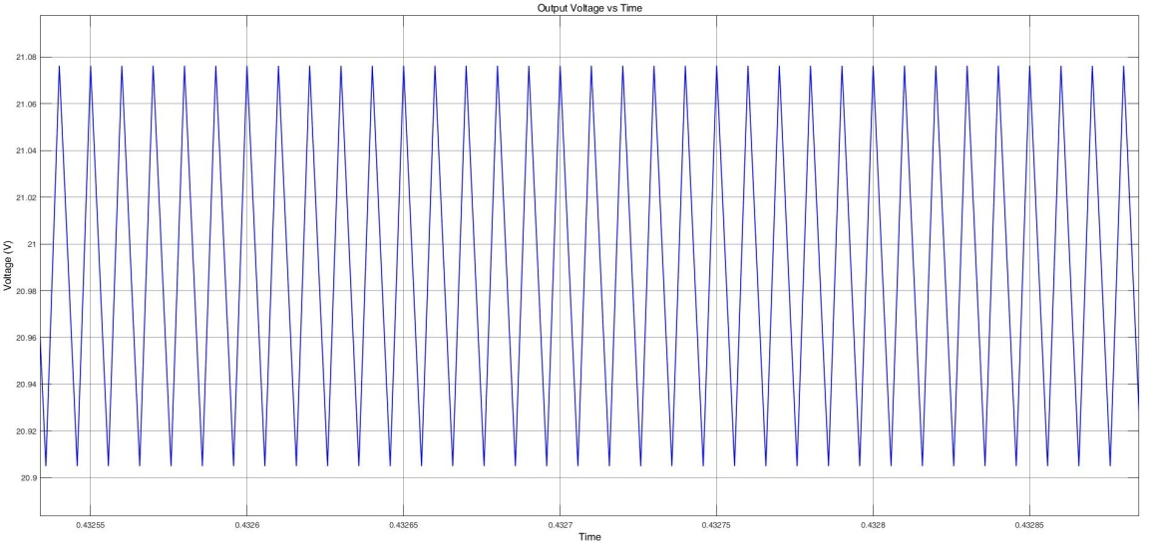

**Figure 9 :**  Ripples

As can be seen from the Figure 8 and Figure 9, simulation results and analytical calculations are consistent. In simulations is ripple free. The reason for that is not understood,probably due to a simulation error.

**CONCLUSION**